Tour ID: 271004  
Tour Name: Iceland: Waterfalls, Hot Springs & Hiking Volcanic Landscapes G Adventures

Tour destinations: ['Reykjavik', 'Hella', 'Húsafell', 'Gullfoss', 'Thingvellir National Park']

Tour destinations images:

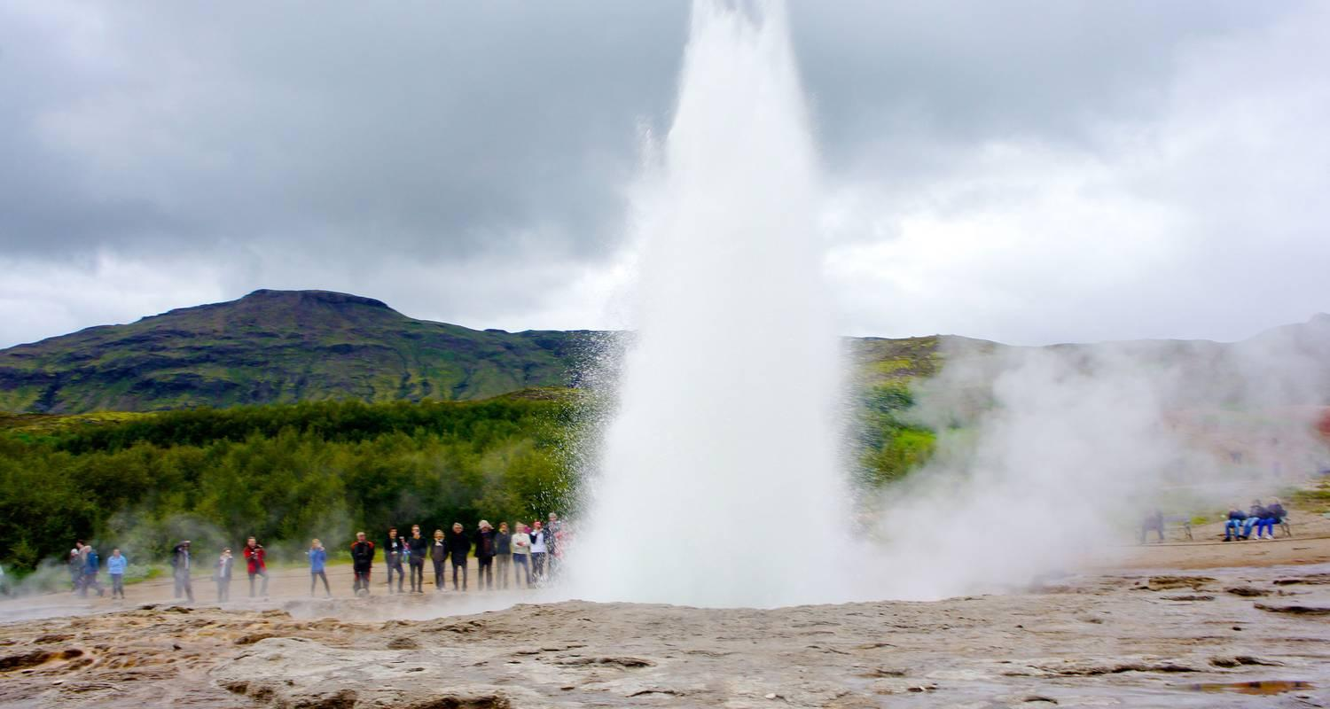

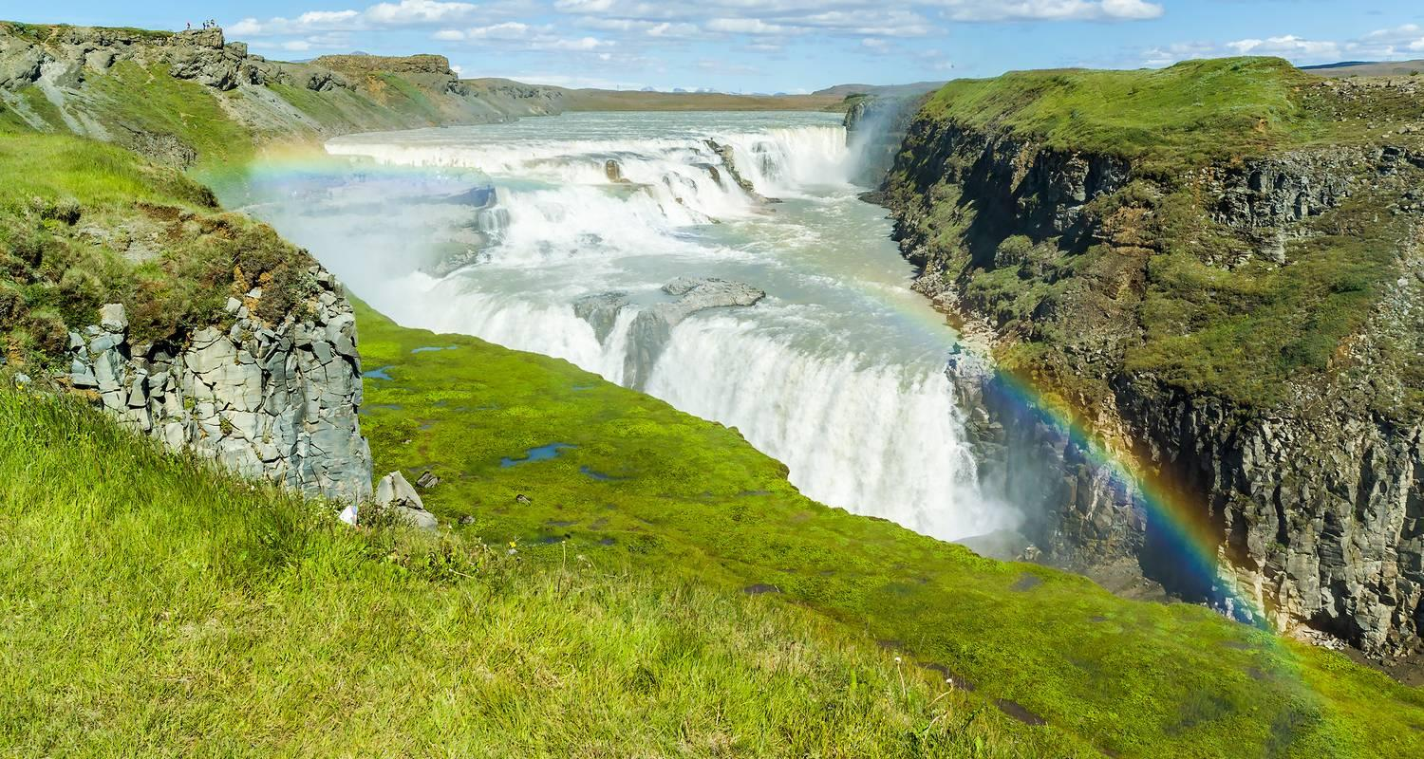

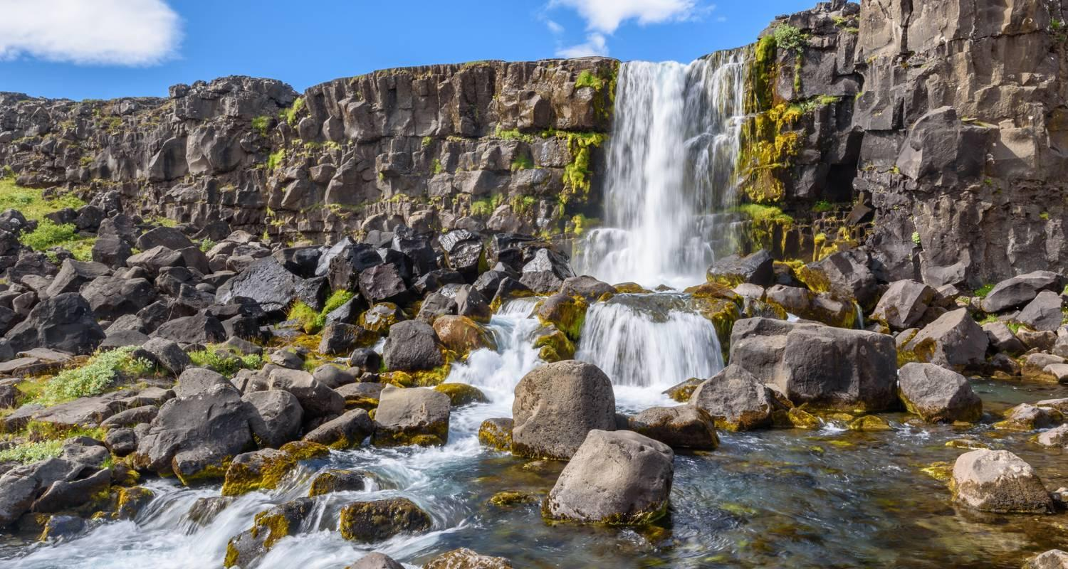

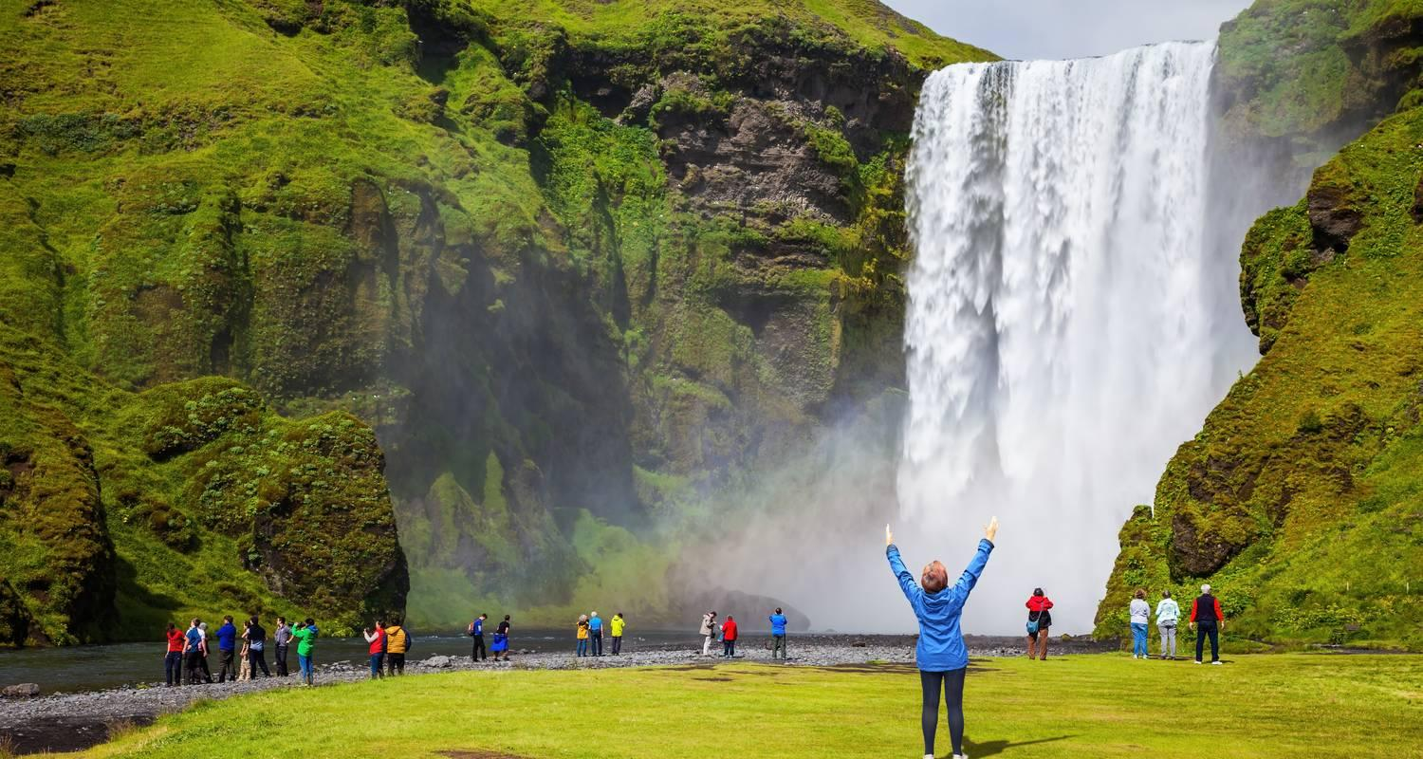

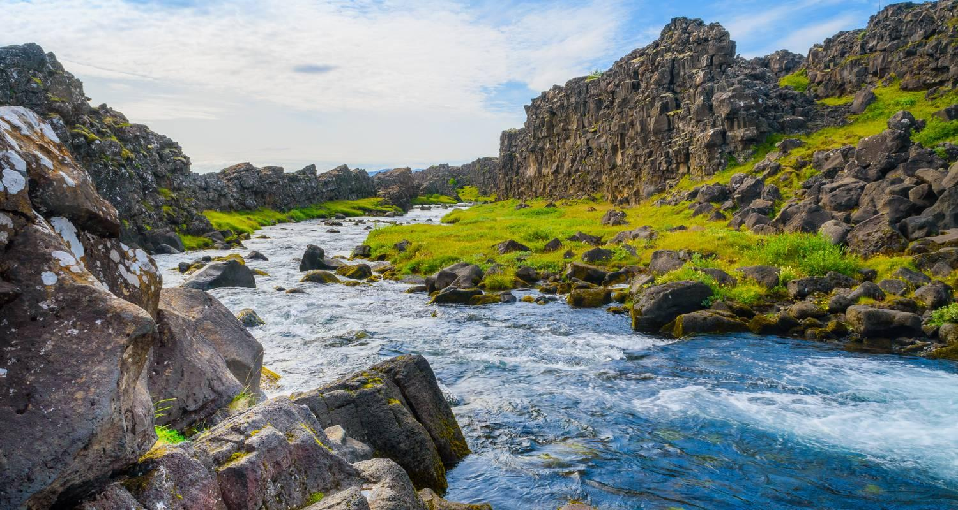

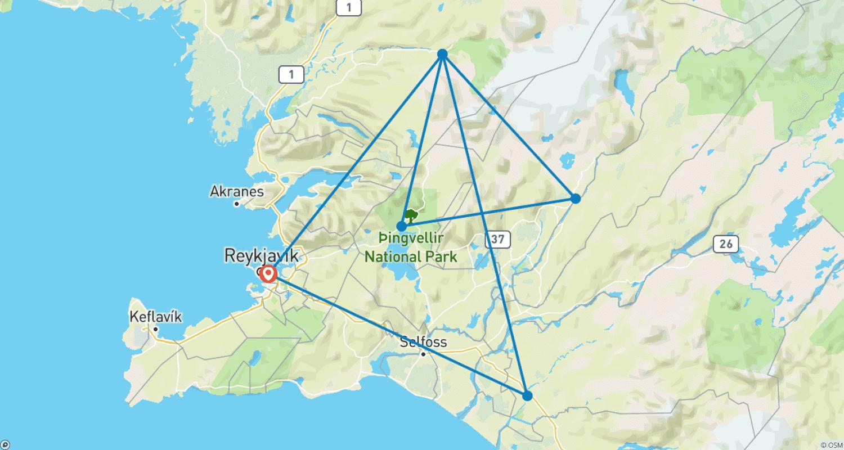

Tour ID: 271006  
Tour Name: Iceland: The Snaefellsnes Peninsula, Volcanoes & Hiking Húsafell

Tour destinations: ['Reykjavik', 'Snaefellsjokull National Park', 'Hella', 'Skogafoss', 'Gullfoss', 'Thingvellir National Park', 'Húsafell']

Tour destinations images:

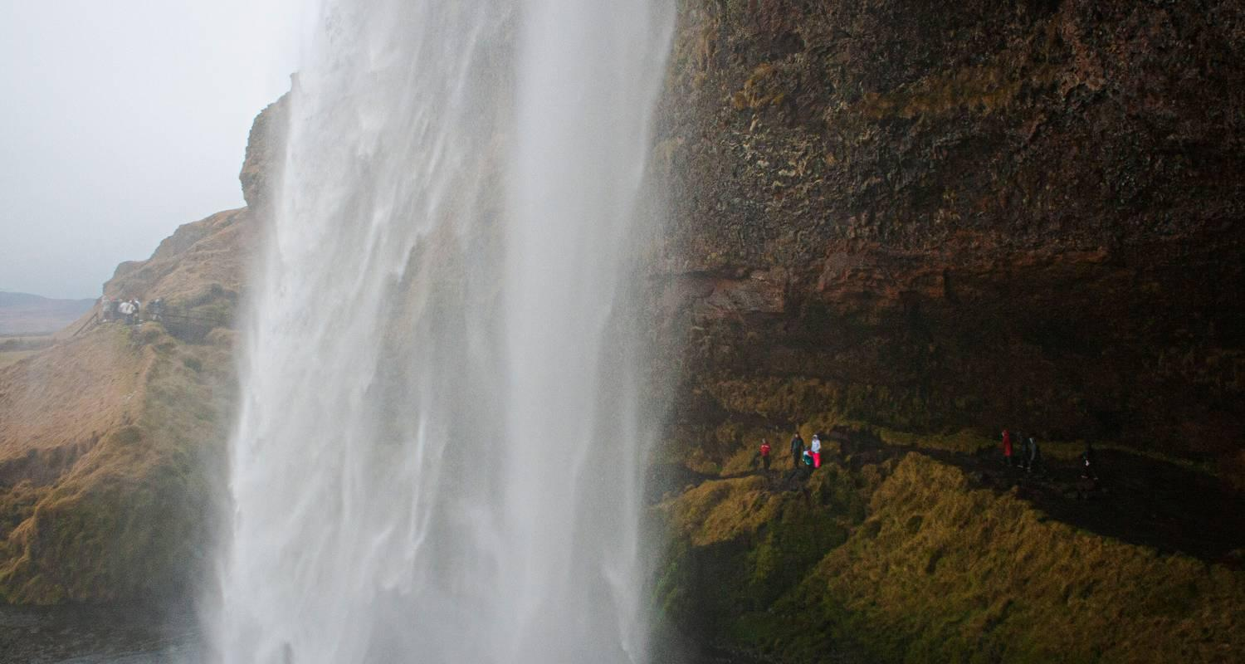

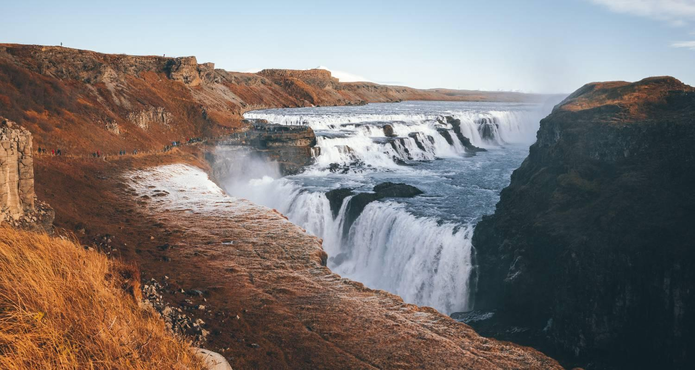

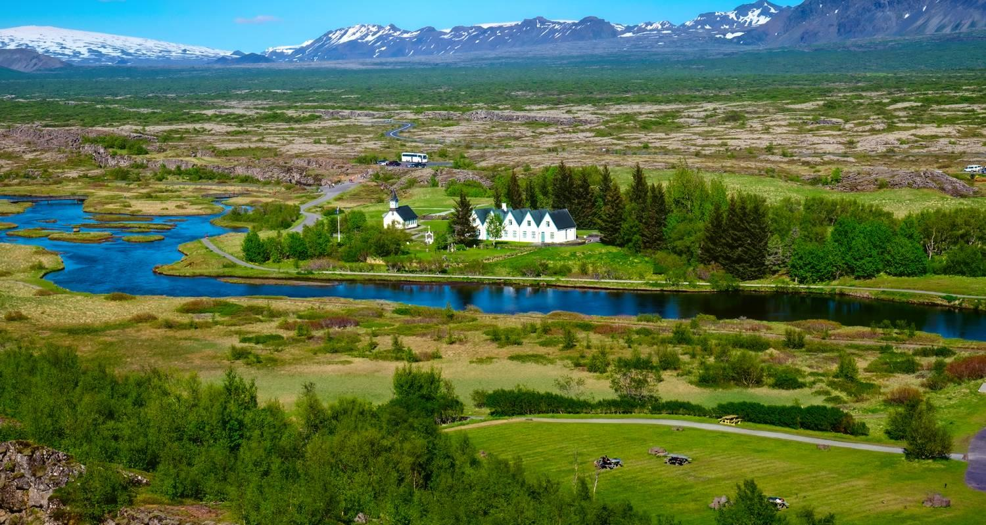

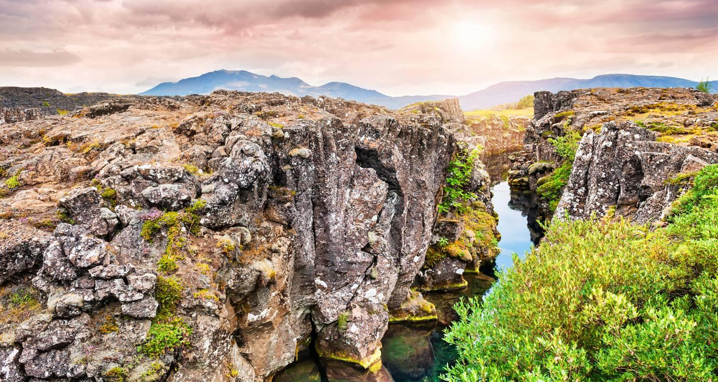

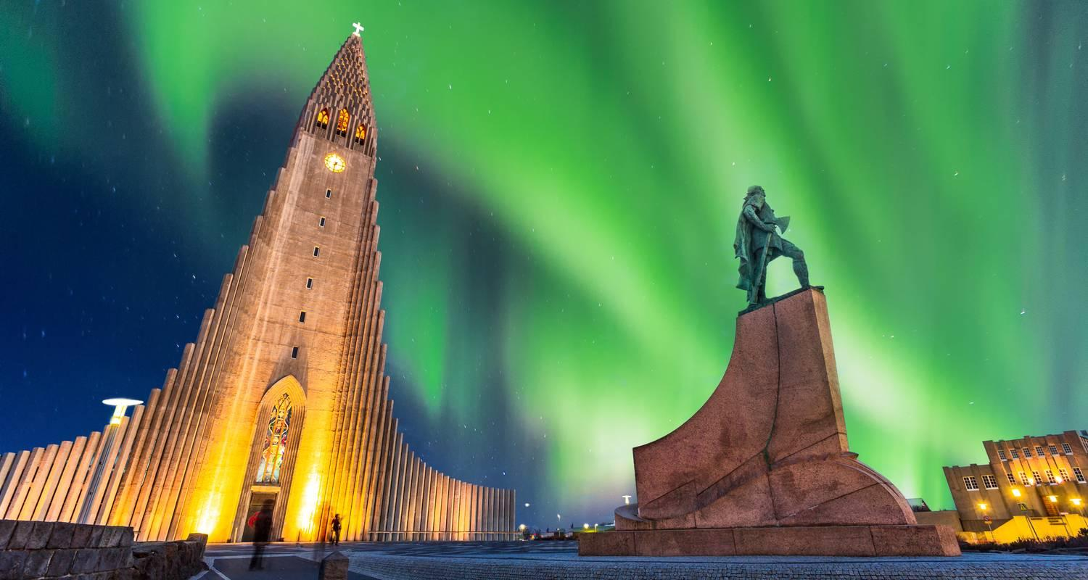

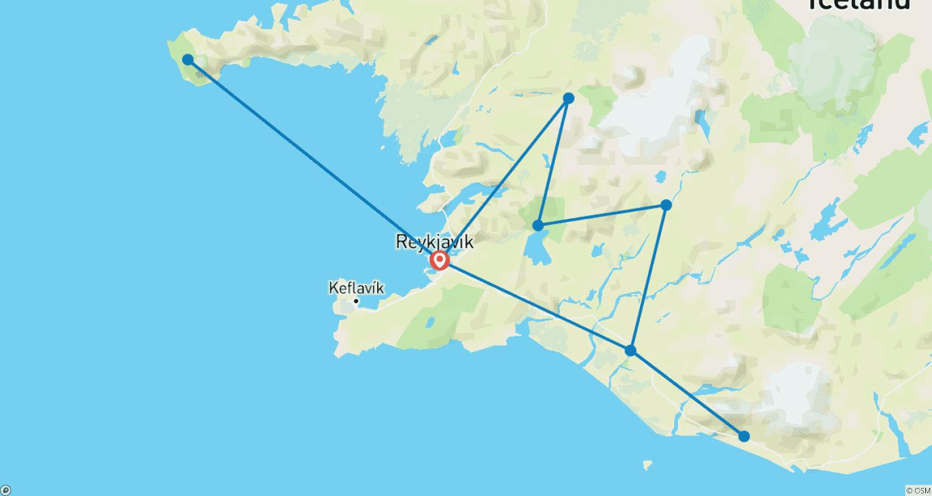

Tour ID: 271088  
Tour Name: NATURAL WONDERS OF ICELAND

Tour destinations: ['Reykjavik', 'Keflavik', 'Geysir', 'Gullfoss', 'Selfoss', 'Skogar', 'Kirkjubaejarklaustur', 'Skaftafell', 'Dettifoss', 'Dimmuborgir', 'Akureyri', 'Siglufjordur', 'Snæfellsnes', 'Stykkisholmur', 'Hellnar', 'Arnarstapi', 'Blue Lagoon']

Tour destinations images:

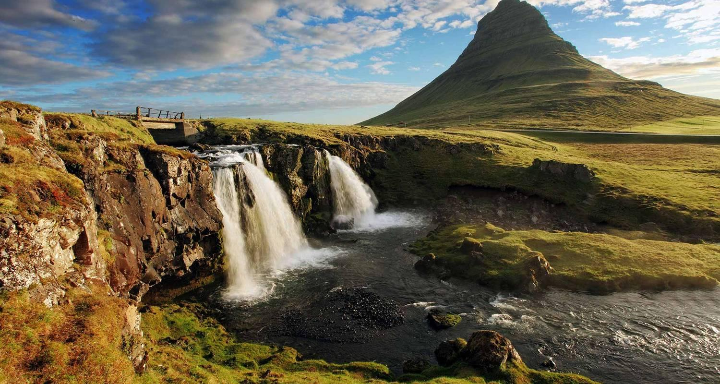

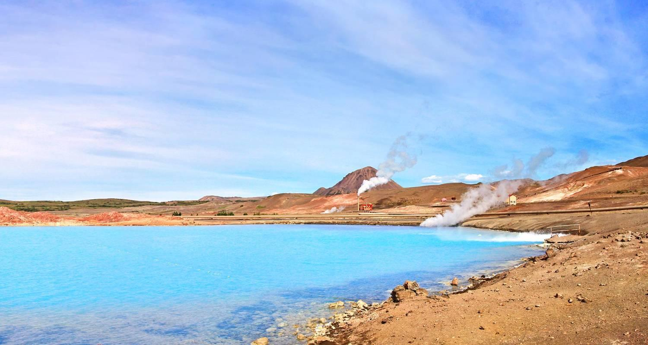

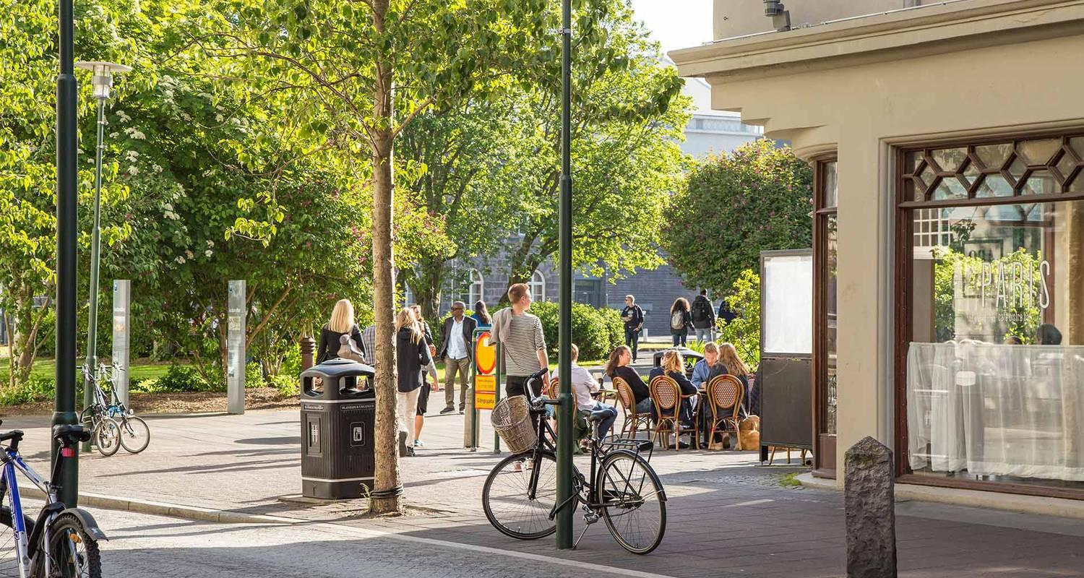

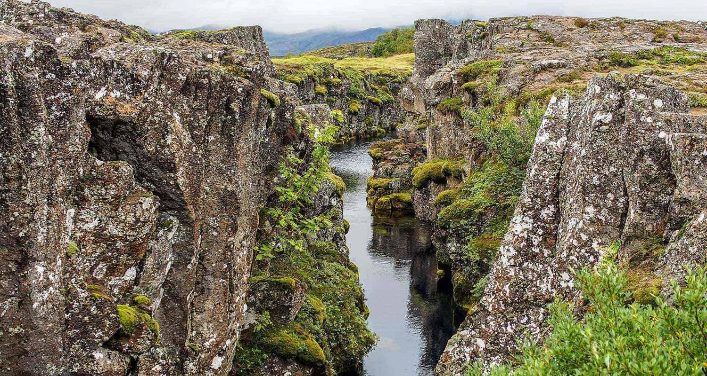

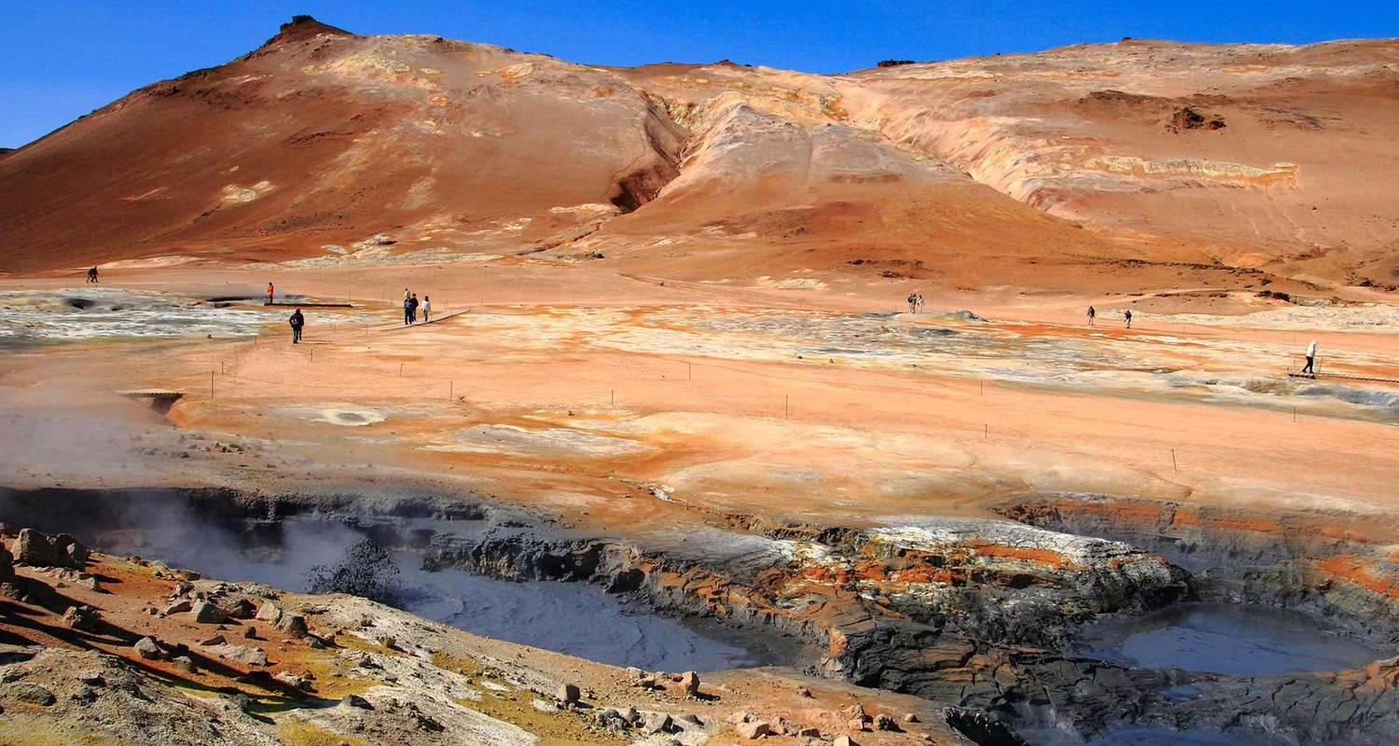

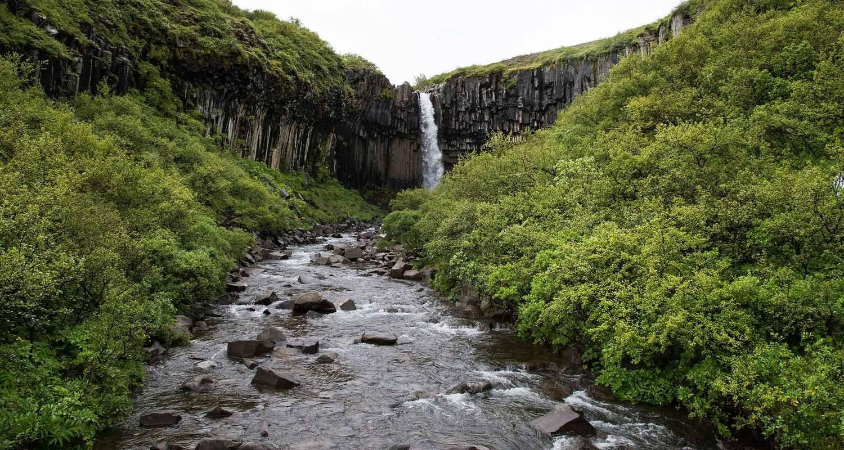

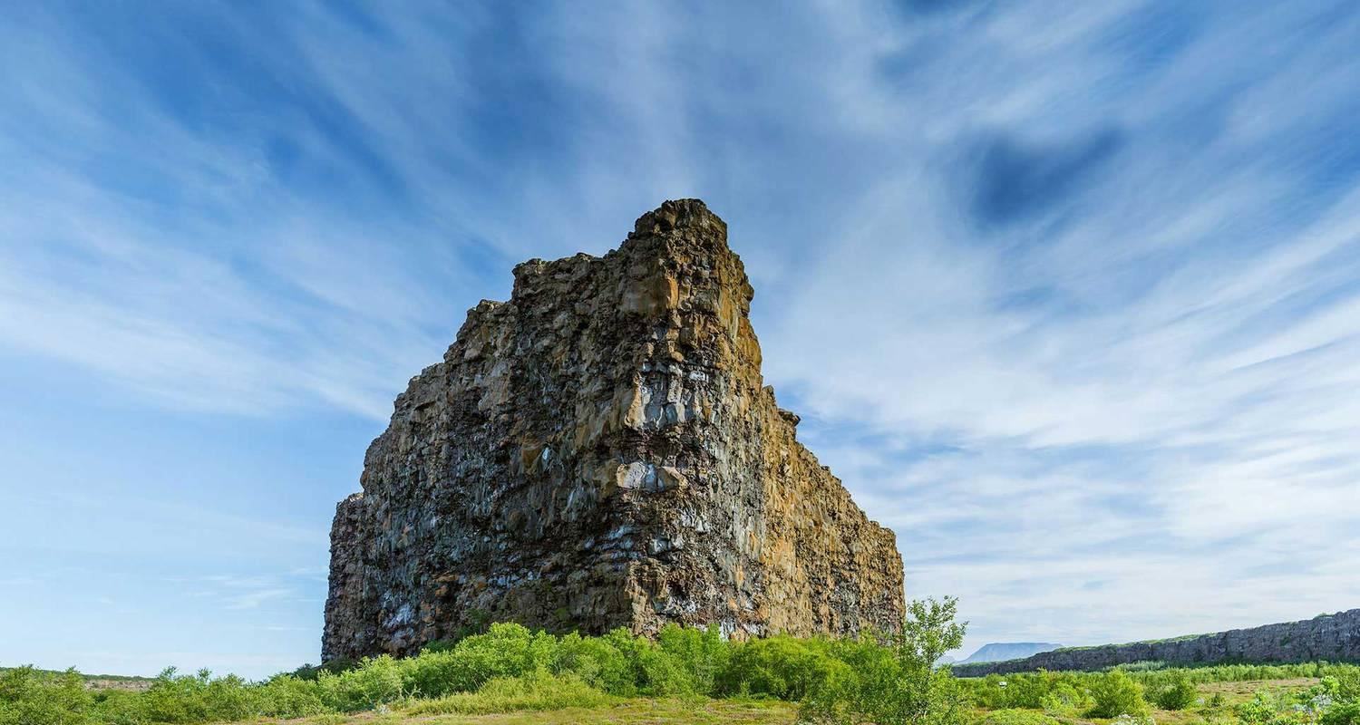

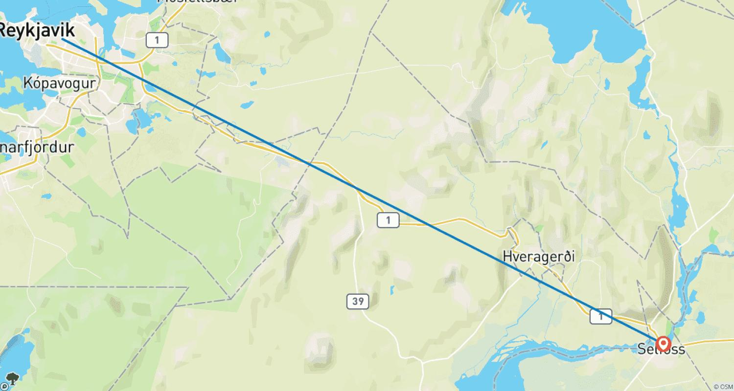

Tour ID: 271496  
Tour Name: ICELAND – 7 Days Golden Circle and South Coast Highlights

Tour destinations: ['Reykjavik', 'Snæfellsnes', 'Borgarfjörður', 'Thingvellir National Park', 'Jokulsarlon', 'Skogafoss']

Tour destinations images:

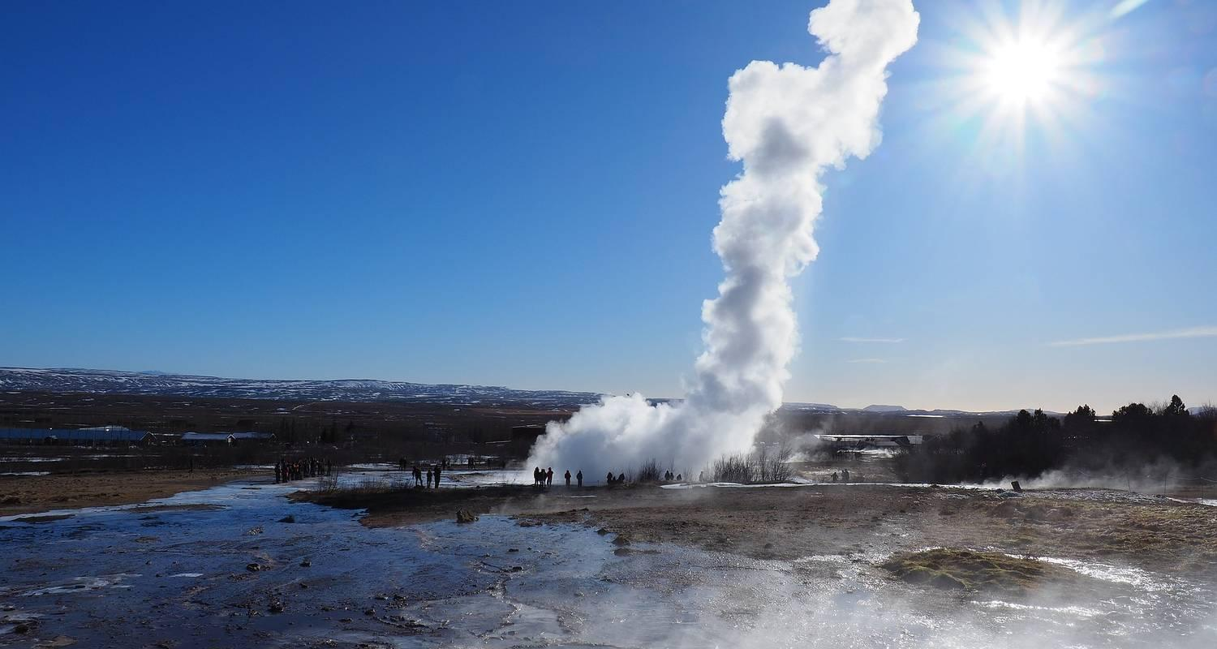

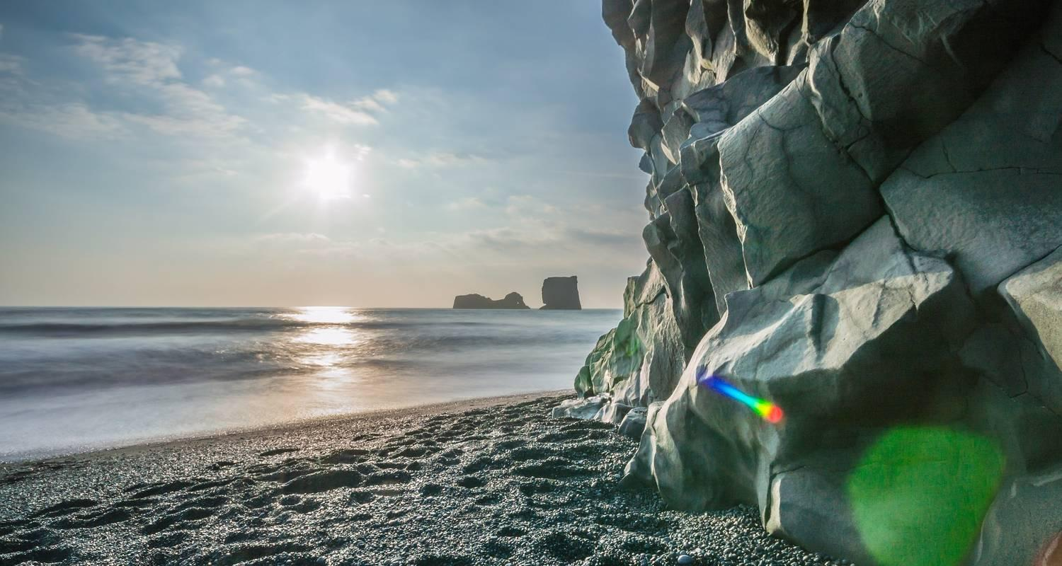

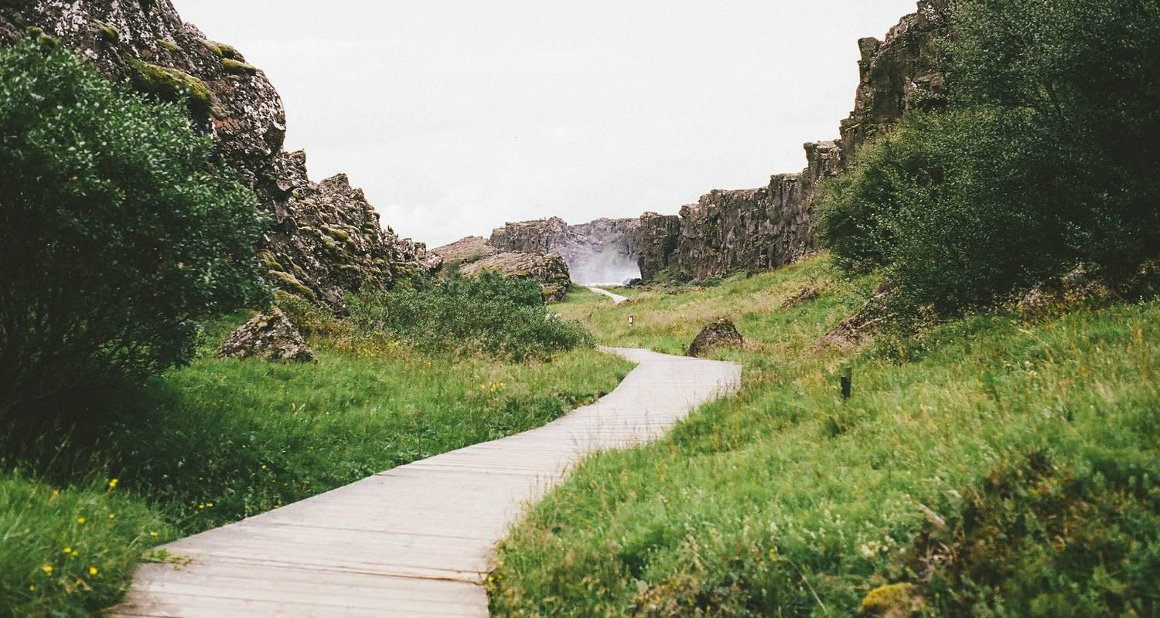

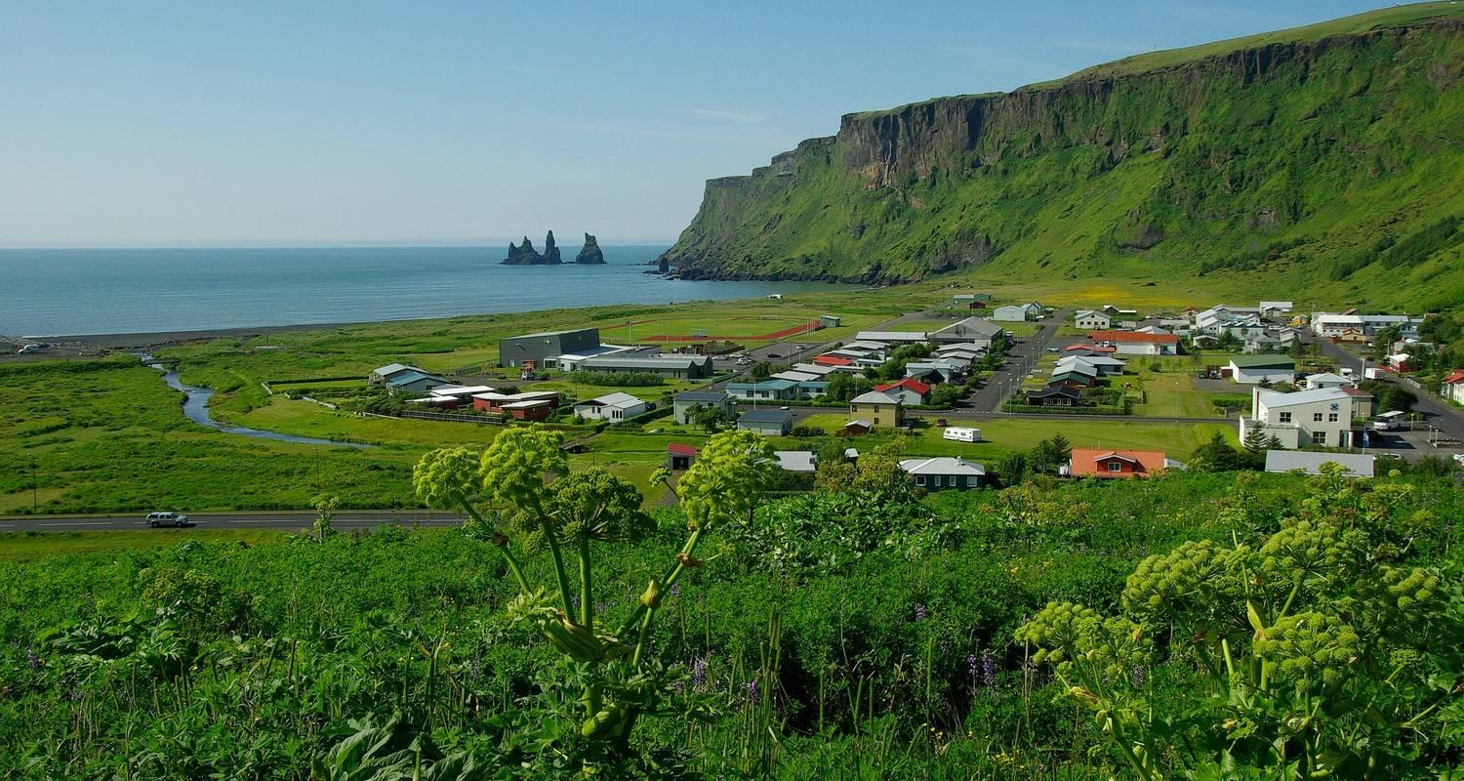

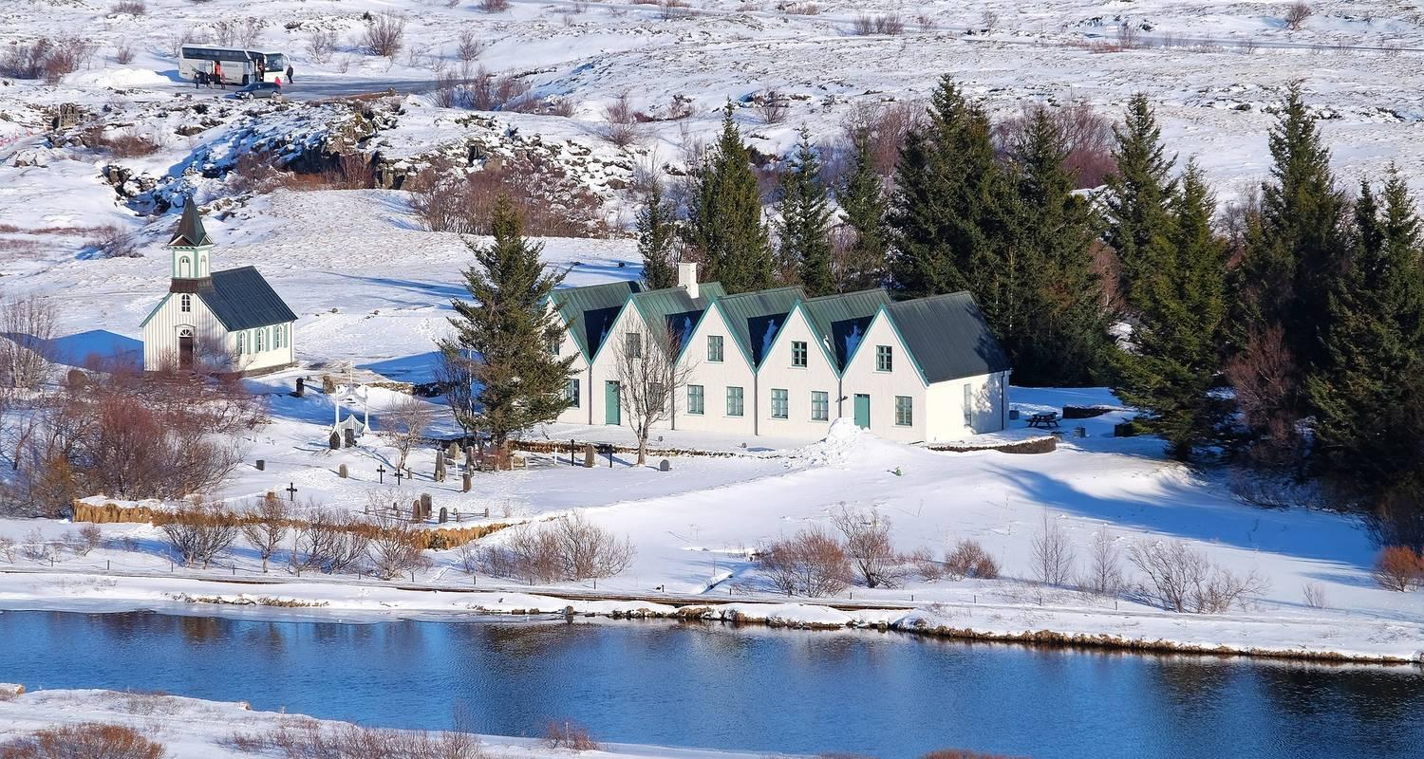

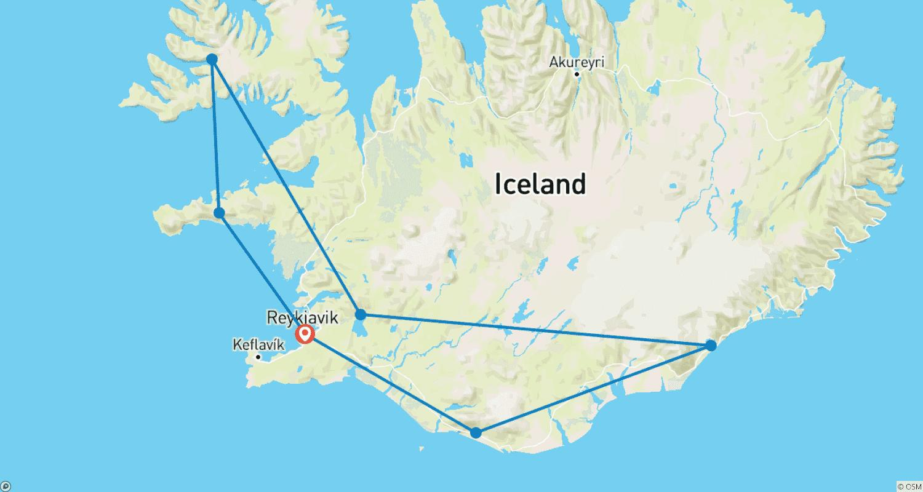

Tour ID: 271497  
Tour Name: Iceland Ring Road 8 Day Adventure with Blue Lagoon

Tour destinations: ['Reykjavik', 'Thingvellir National Park', 'Geysir', 'Hvolsvollur', 'Seljaland', 'Skogar', 'Reynisfjara', 'Vik', 'Kirkjubaejarklaustur', 'Jokulsarlon', 'Hofn', 'Djupivogur', 'Egilsstadir', 'Dettifoss', 'Mount Namaskard', 'Myvatn', 'Dimmuborgir', 'Skutustadagigar', 'Godafoss', 'Akureyri', 'Blonduos', 'Hvitserkur', 'Laugarbakki', 'Grábrók Volcano', 'Hraunfossar', 'Reykholt', 'Borgarnes']

Tour destinations images:











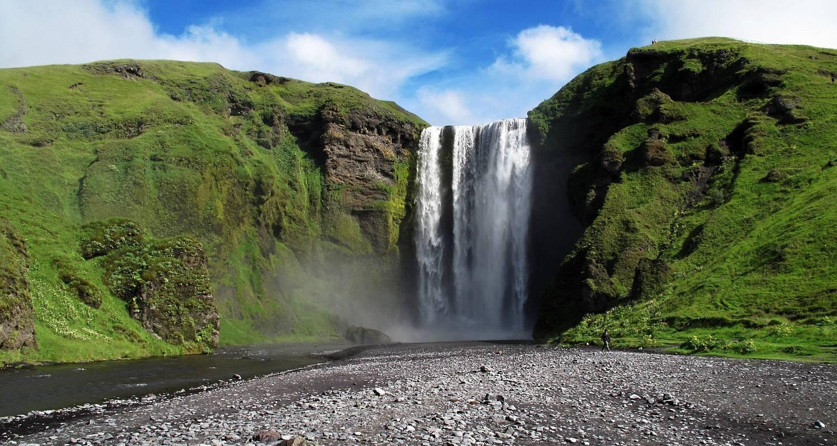

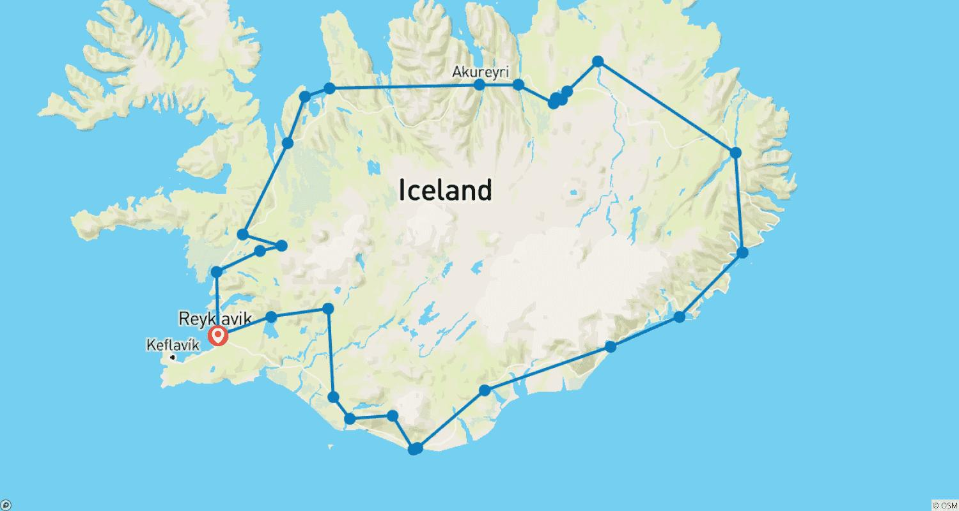

Tour ID: 271699  
Tour Name: Iceland!

Tour destinations: ['Reykjavik', 'Thingvellir National Park', 'Geysir', 'Gullfoss', 'Secret Lagoon', 'Vik', 'Reynisfjara', 'Snaefellsjokull National Park']

Tour destinations images:

